How to register:

As long as you are living within the boundaries of the Practice’s catchment you can register with us.

To register, either come into one of our surgeries and complete a registration form or complete form online by visiting our website. On completion you will be asked to make an appointment with either a nurse or a doctor for a new patient check.

Services available to you from Thornfield Nursing team:

Practice Nurse Clinics and Chronic disease management include:

- Diabetes, Asthma, Heart disease
- Smears & Screenings
- Sexual Health and contraception services including Coils and Implants. Free condoms
- Sexually transmitted infection testing
- Termination of Pregnancy referral
- Maternity Services /Midwife clinics
- Health visiting services
- Baby and Post-natal checks
- Childhood immunisations
- Minor Surgery
- District Nurse Services
- Mental Health Services and Counselling
- NHS Travel vaccinations

Interpreters
Interpreters are available but must be booked in advance, let the members of staff at the surgery know if you would need an interpreter upon booking an appointment. Please ensure that the interpreter is NOT a family member

Opening Hours – and access to services

Molineux Street NHS Centre  Monday & Friday  8:00am to 6:30pm  Selected days  7:00am – 9:00pm  (Please ask for details)  Thursday - 12:30 – 1:30pm closed | Shieldfield Health Centre  Monday to Friday 8:45am to 5:15pm  Thursday - 12:30 – 1:30pm closed

How to contact us

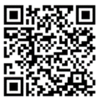
We use an online form accessed via SystmConnect as the main way to access our services. This can be accessed via our website or by scanning the QR code with your mobile phone or tablet:

You can still contact us via telephone if you are unable to complete a SystmConnect or access the internet.

Home visits

To assist the practice please try to be seen at the Surgery. Home visits are for patients who cannot get to the Surgery i.e. the House bound or very ill.

Please contact the surgery either by telephone or by SystmConnect. A Clinician may contact you to discuss your visit prior to visiting.

Out of Hours arrangements

Please ring the number of the Surgery and you will be given advice on ringing 111 Out of Hours Service after 6:30pm and before 8:00am Monday to Friday and all day Saturday and Sunday.

NHS 111

Telephone number 111 or visit https://111.nhs.uk
This service offers healthcare advice 24 hours per day.
Urgent Appointments

If you need to book an urgent appointment you can contact the surgery via telephone or SystmConnect. Your call or SystmConnect will be answered by a Care Navigator who will ask questions to help navigate you to the most appropriate service or clinician – for example, a GP, Nurse, Advanced Nurse Practitioner, Clinical Pharmacist, Walk in Centre, NHS 111.

Extended Hours

Our Surgery is now offering early morning appointments from 7:00am, evening appointments from 6:30pm and Weekend appointments on selected dates. Please see reception for details and to pre-book your appointment.

Repeat Prescriptions

You may obtain a repeat prescription for your medication (provided your doctor has authorised it) by contacting our prescription line on option 2 which is open Monday to Friday 9am – 11am, order via the NHS app, SystmConnect or by coming to the surgery in person.

Your prescription should be ready to collect at your nominated pharmacy in two working days.

Appointments

- Please help us by keeping your appointment. If you cannot make your appointment, please let us know and we can rearrange it for you.

- Appointments are for one person only.

- Book a double appointment for more than one issue.

- Sign up for our text messaging service – it helps you remember when you have an appointment booked and allows you to cancel at any time.

- Please contact us via telephone if you wish to cancel your appointment within the hour so we can offer it to someone else.
Suggestions for improvements and complaints

We welcome your suggestions for improvements to our service. If there is something bothering, you let us know. If you have a complaint, please either ask a member of staff to pass over your details or you can write to us. All complaints will be investigated and replied to within 2 weeks.

Zero Tolerance on Violence and Abusive behavior

This Practice along with all NHS services operates a zero-tolerance policy on violence and abusive behavior. If you are violent or abusive whilst in our Surgery, you will be removed from our list.

Access to patient records and disclosure of information

All patients have the right to view their medical records. Please complete a medical records form, these can be found at reception or on our website.

Accessibility:

All premises are accessible by wheelchair. Should you require any assistance in entering any of our surgeries please call us in advance and we will be happy to help. We also have induction loops for hearing aid wearers.

Reasonable Adjustments:

Reasonable adjustments refer to changes made to ensure that all people can access healthcare services equally. Examples include:

- Communication support
- Appointment flexibility
- Assistive technology
- Health and care passports

If you would like more information or feel as though you would benefit from a reasonable adjustment, please contact the surgery.

Molineux Street NHS Centre

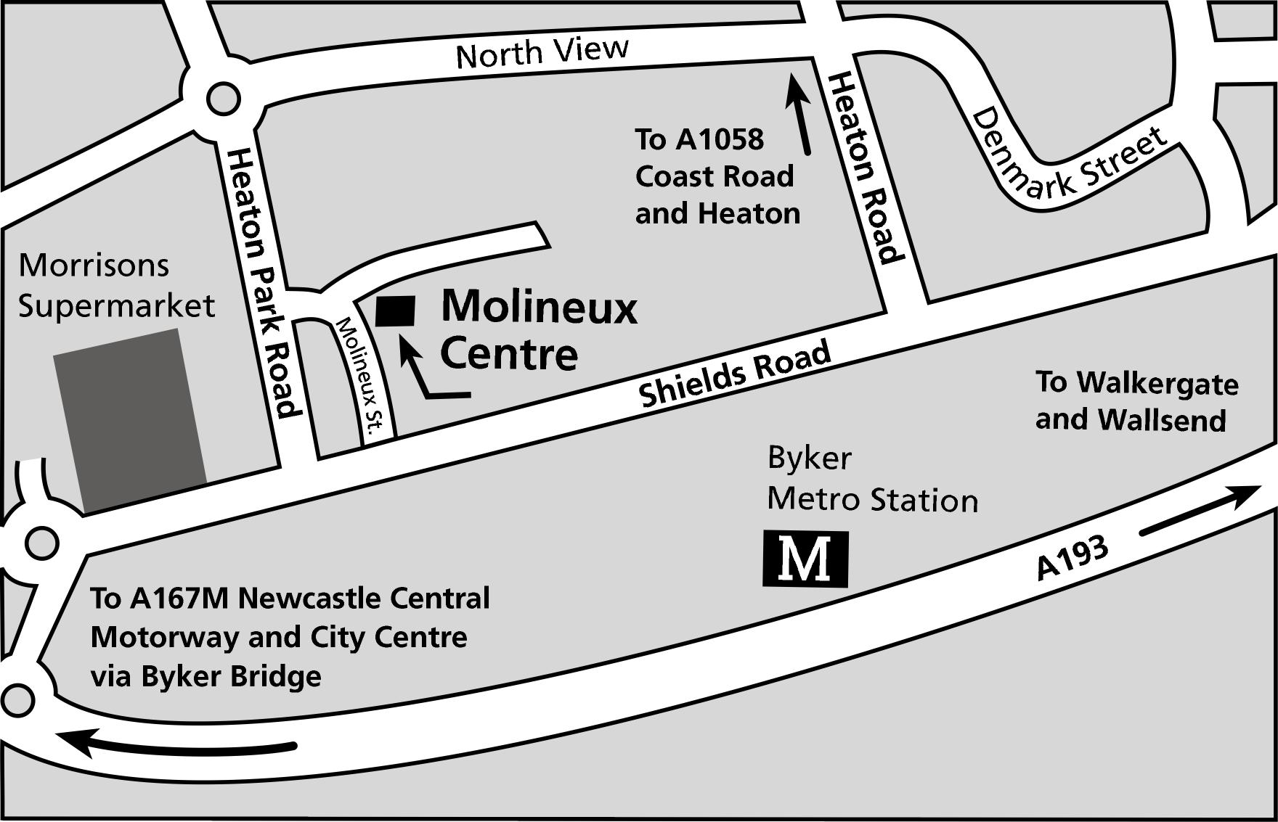

Shieldfield Health Centre

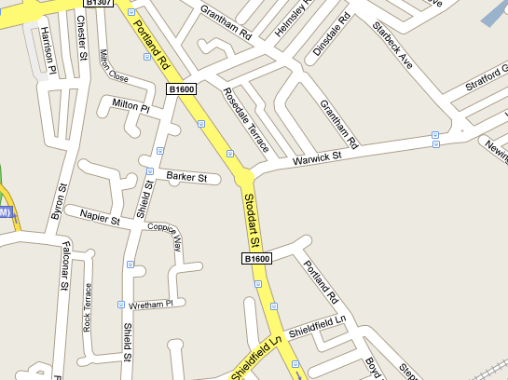
Thornfield MG at Shieldfield



Molineux Street Shieldfield Health

NHS Centre Centre
Molineux Street, Stoddart Street
Byker, Shieldfield
Newcastle upon Newcastle upon
Tyne Tyne

NE6 1SG NE2 1AL

Tel: 0191 275 5740

Practice Partners
Dr N Crowe, Dr RP Gray, Dr C Watson,
Dr K Senior, Mrs. T Stuchlik

Doctors
Dr L Wakerley, Dr S Graham, Dr R Coles, Dr Coipel, Dr Taqvi, Dr Tee, Dr Thomas, Dr Budas, Dr Tait, Dr Dobson, Dr Amin and Dr Dodds

Practice Manager
Mrs. Caroline Forrest

Deputy Practice Manager
Helen Scott

Please visit the Practice website for further information:
http://www.thornfieldmedicalgroup.org.uk/

