  
Training of staff in use of Systm1 and other IT training as needed.

61% were 'Clinical' requests and 39% were 'Administrative' requests.

Since introducing SystmConnect our incoming demand has increased, meaning that we are more accessible for patients, the below data demonstrates this.

In August 2024 we had a total of 4,219 requests submitted, and in March 2025 we had a total of 5,913.

Meaning the practice has had an additional 914 requests submitted meaning the demand for has increased by 33.4%.

During the month of March 2025, we had a total of 5,913 SystmConnect requests from patients.

Welcome to our latest newsletter, we will be sharing the latest updates here at the practice and some important information with you!

SystmConnect

Systmconnect is the new way to contact us and access our services, it requires an online form to be completed.

The Care Navigators view the form and signpost patients to the most appropriate service for their care. This could be a Doctor, Advanced Clinical Practitioner, Pharmacist, Pharmacy, Nurse, Walk in Centre, or A&E.

We still have the phone line available for those who are unable to access the internet, we would be very grateful if you could submit an online form

Phone update

We have recently upgraded our phone system which allows some extra features. This means our phone options have changed as follows:

Option 1. Link to SystmConnect website

Option 2. Cancel appointment

Option 3. Prescription line 9am-11am.

Option 4. Speak to a Care Navigator

More information can be found on the following page with regards to the changes and how this may benefit you.



May – August 2025

NEWSLETTER

**Phone update March 2025**

We have recently upgraded our phone system which allows some extra features. This means our phone options have changed as follows:

**Option 1**. Link to system connect

Pressing option 1 automatically send a text message to your mobile with the link to the SystmConnect submission page.

**Option 2.** Cancel

The cancel options allow you to leave a message to cancel your appointment, please make sure you leave as much details as possible.

Please do not leave a message if you're cancelling your appointment within the hour of the appointment time, we would appreciate it if you spoke to us direct.

**Option 3.** Prescription line 9am -11am

We now have a prescription line which is open Monday to Friday between 9am and 11am. This is for patient's who are unable to order their medication online.

Once through to the prescription line, you will be placed in a queue, once it is your turn a member of staff will answer the phone to take your prescription request. Please have the details of your medication ready.

**Option 4.** Care Navigator

Option 4 will put you through to a Care Navigator, please note we will direct you to complete an online consultation unless you're unable to access or use online services.

We also have a new call back option. When you reach number 8 or more in the queue it will ask you if you would like a call back from the surgery rather than wait in the queue.

Once it has reached your turn, you will receive a call from the surgery so please keep your phone to hand!

**Upcoming Practice Closures**

**Friday 18th April 2025 – Bank Holiday**

**Monday 21st April 2025 – Bank Holiday**

**Monday 5th May 2025 – Bank Holiday**

**Thursday 8th May 2025 from 13:00PM**

**Monday 26th May 2025 – Bank Holiday**

**Tuesday 10th June 2025 from 13:00PM**

**Wednesday 2nd July 2025 from 13:00PM**

**Monday 25th August 2025 – Bank Holiday**

**Tuesday 9th September 2025 from 13:00PM**

**Wednesday 5th November 2025 from 13:00PM.**

If you need assistance during this time please visit a Walk in Centre, call 111 or in an emergency dial 999.

**Social Prescribing Link Workers – SPLW Team**

SPLWs connect people to community-based support, including activities and services that meet practical, social, and emotional needs that affect their health and wellbeing. This includes connecting people to statutory services for example housing, financial and welfare advice.

Some things the SPLWs can help with:

* Housing
* Benefits
* Financial problems
* Letters
* Power of attorney
* Getting food parcels/food vouchers/ clothing/appliances/utilities/toiletries
* Homelessness
* Bereavement/mental health/loneliness
* Support with appointments
* Addiction support

If they can't help you directly, they will try their very best to find someone or something that can!

Speak to a Care Navigator or one of the Clinicians if you feel as though you could use their help.

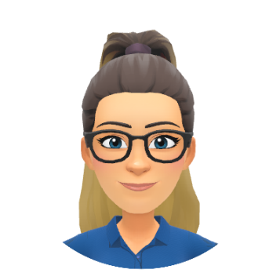

**Travel Vaccinations**

With summer and holidays fast approaching, you may need to think about whether you need any vaccinations if you are planning a trip abroad.

It is important that you contact us as soon as possible so we can arrange an appointment to get you vaccinated. We are unable to accept any requests which may be less than 4 weeks of travel.

To get travel/vaccine advice you will need to complete a risk assessment, this is then passed over to our Practice Nurse who will go through your notes and assess your risk.

To complete a risk assessment, you can visit our website and search TRAVEL in the search box to find our risk assessment or you can submit a SystmConnect.

**Kristie – Nursing Associate**

Kristie is a very experienced Nursing Associate and has recently moved to Thornfield from another GP surgery.

She can do dressings, immunisations, annual reviews, cervical screening and much more!

**Chelsea - Care Navigator**

Chelsea started working at Thornfield in March, and I am currently in training to be a Care Navigator.

She will be learning to navigate patients to the correct service whilst supporting the clinical staff with administrative tasks.

**Rhiannah – Apprentice Care Navigator**

Rhiannah is currently in the process of completing a Business and Administration apprenticeship.

She has recently transferred her apprenticeship from another GP surgery to Thornfield Medical Group and, will be learning to become a Care Navigator alongside gaining a qualification.

New staff at Thornfield Medical Group

COPD

ASTHMA

EPILEPSY

HIGH BLOOD PRESSURE

DIABETES

**Annual Reviews**

There is good evidence that patients who live with a long-term health condition, live longer when their condition is well managed. We also need to make sure that any medications that we give are helping you live well but also not causing any unintended harm. Therefore, it is very important that you are assessed to make sure that the best things for you are happening.

We will invite you to attend appointments in or around your birthday month so that all your health conditions can be reviewed together.

If you haven't received a message, please contact the surgery to check your eligibility.

Local Help

Our local area has a lot to offer if you are struggling.

You can visit the below link [www.feedingfamilies.org.uk/get-help/](http://www.feedingfamilies.org.uk/get-help/) which has some useful links to help navigate you to the correct help in your area. If not, ask to speak to one of our Social Prescribers!

Some local help:

* CAP Debt Counselling, call 0800 328 0006 to arrange an appointment.
* Search Trussell Trust to find local food banks.
* Peoples Kitchen can provide a free hot meal daily.
* Vinnies Kitchen, Byker Bridge, you can get 10 items for £5.00.
* Newcastle Pop Up Pantry – google to find local pop-up areas and dates.
* Food Cycle:

Every Thursday 7pm at St Silas' Church, Clifford Street, Byker, NE6 1DR.

Every Wednesday 12:30pm at Monkchester Community Centre, Monkchester Road, Walker, NE6 2LJ



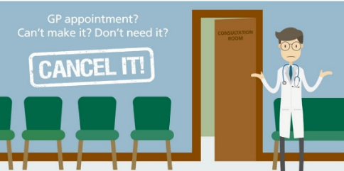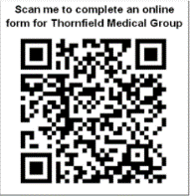

Scan the QR code to complete an online request form.

This can be used for both clinical and administrative requests including home visits, fit notes, letters, and medication.

If you're unable to use online, please let us know and we will look to see how we can help you.

You can also order your medication by using the NHS app or by handing in a paper request into reception.

*Please note all medication requests take 2 working days to be processed and sent to your nominated pharmacy.

A big thank you to all our patients who responded to a recent text asking for your opinions of cancer services.  Your input is really appreciated.  Thornfield was in the top 3 in the country for the number of responses and this will all really help shape future services.  Thank you!

**DR R COLES**

During the month of March 2025 416 patients did not attend their Clinical appointments

44% of missed appointments were with a Doctor or Advanced Nurse Practitioner.

56% of missed appointments we with a Nurse or Health Care Assistant.

In total this equates to 104 hours of Clinical time wasted through patient not cancelling their appointments.

If you cannot make your appointment, please let us know so we can give it to someone else.

To cancel you can press option 1 on our phone line, reply to your reminder SMS message or cancel via the NHS app.

Friends and Family Test

We value your feedback on our services. The Friends and Family Test (FFT) is an important tool that allows the opportunity for feedback on your experience with Thornfield Medical Group.

Listening to your views helps identify what is working well, what can be improved on and how.

We publish the data monthly on the practice website.

To submit feedback please scan this QR code!

Healthier Together Programme

The Healthier Together website and app is a great place to find accurate and trusted health advice in the Northeast. All the information has been checked by clinicians to ensure the advice offered is to the highest standards.

You can find advice relating to poorly babies, children, carers, young people and expecting mothers.

It can advise on a range of common conditions and what the best course of action should be like visiting A&E, GP, Walk in Centre, or Pharmacy by using a walk-through symptom checker.

Visit https://www.nenc-healthiertogether.nhs.uk/ or scan the QR code on the back of this newsletter to download the app!



**SCAN ME**

