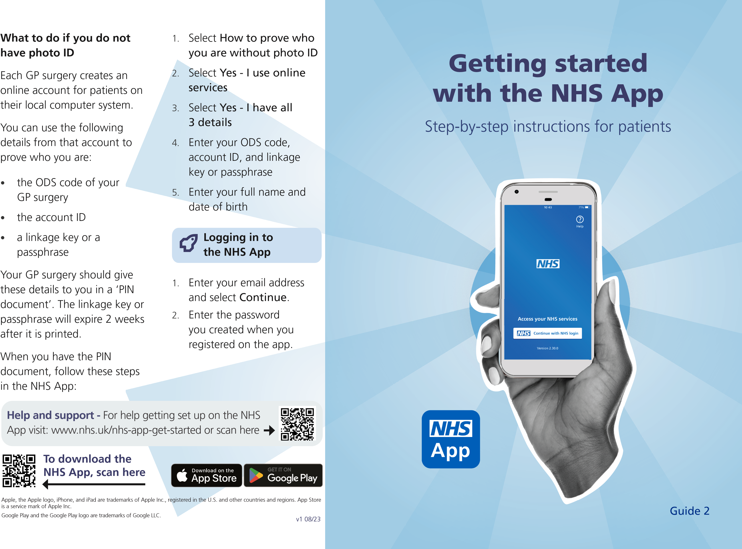

**How to register and get full use of NHS App services**

**Installing the app** 4. We will email you a security

code. Enter this code in the

|  |  |
| --- | --- |
| 1. Open the App Store or Google Play. 2. Search for ‘NHS App’. 3. Install the app. | NHS App to confirm your email address.   1. Enter your mobile phone number and select Continue. 2. We will send you another |

|  |  |
| --- | --- |
| If you already have an NHS login account for other apps and websites you can use the same email address and password to log in. | the NHS App to confirm your mobile phone number.  7. If you have entered the correct codes, you can access the NHS App.  You will now have an NHS login. |

security code in a text message. Enter this code in

**Registering**

To create an NHS login account, you must be aged 13 or over, and have an email address and phone number:

1. Enter your email address and select Continue.
2. Choose a password.
3. Accept the NHS login terms and conditions.

**Proving who you are**

You will need to prove who you are to access other services like seeing your GP health record and other personal information.

**Use photo ID to prove who you are**

You will need a form of photo ID such as a valid UK passport or UK driving licence.

You have two options.

# Option 1 - Complete a face scan

Through the NHS App, NHS login will guide you on how to:

1. Take a photo of your ID with your mobile phone.
2. Complete an automated scan of your face using your mobile phone. This will be used to match your face with the photo ID.
3. Enter your date of birth.
4. Enter your NHS number or your name and postcode.

When you have completed these steps, your identity should be confirmed within a few hours.

# Option 2 – Take a video

Through the NHS App, NHS login will guide you on how to:

1. Take a photo of your ID with your mobile phone.
2. Record a short video of your face and say 4 randomly generated numbers (you can also use British Sign Language or write the numbers down and show them in the video).
3. Enter your date of birth.
4. Enter your NHS number or your name and postcode.

When you have completed these steps, your identity should be confirmed within a few hours.